# Methodologies in Selected Studies

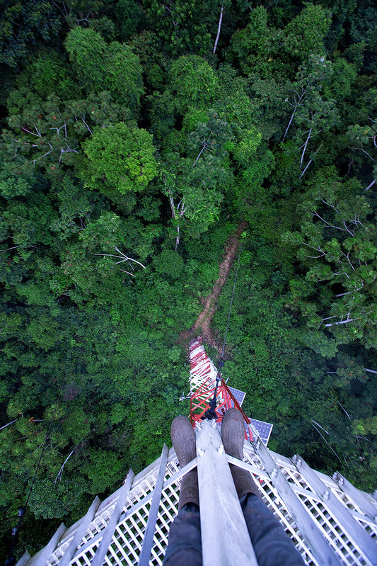  
*Figure: Acoustic sensor tower deployed in a forest to monitor logging sounds.* In Singh *et al.* (2024), the authors build a wireless acoustic sensor network (WASN) that processes recorded sound on the edge. Each node computes a Short-Time Hartley Transform (STHT) spectrogram to extract low-level features from ambient audio, then applies machine‐learning classifiers (kNN, Decision Tree, Random Forest, AdaBoost, SVM) on a 32-bit microprocessor[[1]](https://www.researchgate.net/publication/382339283_Real-Time_Monitoring_of_Illegal_Logging_Events_Using_Intelligent_Acoustic_Sensors_Nodes" \l ":~:text=computations%20within%20the%20nodes,bit). Once a chainsaw or logging sound is detected, the node sends a LoRa alert to a gateway. This real‐time scheme was prototyped in the lab (simulating forest sounds via loudspeakers) and achieved ~96.6% accuracy[[2]](https://www.researchgate.net/publication/382339283_Real-Time_Monitoring_of_Illegal_Logging_Events_Using_Intelligent_Acoustic_Sensors_Nodes" \l ":~:text=intelligent%20acoustic%20sensor%20nodes%20,respectively). In contrast, Ramadan *et al.* (2024) use low-cost IoT microphone nodes that feed a convolutional neural network (CNN) for chainsaw sound recognition[[3]](https://repository.adu.ac.ae/items/81bfae9a-0831-49d8-9396-feb00891c9e1/full" \l ":~:text=paper%20introduces%20a%20novel%20Unmanned,and%20light%20alarms%20to%20deter). Their system transmits detections over LoRaWAN to a cloud server, which then dispatches a camera-equipped drone to the site for visual confirmation of illegal activity[[3]](https://repository.adu.ac.ae/items/81bfae9a-0831-49d8-9396-feb00891c9e1/full" \l ":~:text=paper%20introduces%20a%20novel%20Unmanned,and%20light%20alarms%20to%20deter). The CNN-based approach was tuned to run with very low power (8-year battery life) and achieved ~99.4% classification accuracy in tests[[4]](https://repository.adu.ac.ae/items/81bfae9a-0831-49d8-9396-feb00891c9e1/full" \l ":~:text=human%20presence,time%20solution%20for%20detecting).

## Differences in Objectives and Outcomes

* **Goals:** Singh *et al.* aim solely to detect logging sounds acoustically for monitoring purposes[[1]](https://www.researchgate.net/publication/382339283_Real-Time_Monitoring_of_Illegal_Logging_Events_Using_Intelligent_Acoustic_Sensors_Nodes" \l ":~:text=computations%20within%20the%20nodes,bit). Ramadan *et al.* explicitly target both *detection* and *prevention* – once a chainsaw is heard, their system triggers an immediate drone response to deter illegal loggers[[3]](https://repository.adu.ac.ae/items/81bfae9a-0831-49d8-9396-feb00891c9e1/full" \l ":~:text=paper%20introduces%20a%20novel%20Unmanned,and%20light%20alarms%20to%20deter).
* **Techniques:** Singh *et al.* rely on classical audio processing (STHT spectrograms) and traditional ML classifiers on resource-limited hardware[[1]](https://www.researchgate.net/publication/382339283_Real-Time_Monitoring_of_Illegal_Logging_Events_Using_Intelligent_Acoustic_Sensors_Nodes" \l ":~:text=computations%20within%20the%20nodes,bit). In contrast, Ramadan *et al.* employ a modern deep-learning approach (a CNN) on IoT edge nodes for sound classification[[3]](https://repository.adu.ac.ae/items/81bfae9a-0831-49d8-9396-feb00891c9e1/full" \l ":~:text=paper%20introduces%20a%20novel%20Unmanned,and%20light%20alarms%20to%20deter).
* **System Design:** Singh’s system is a stand‐alone acoustic node that alerts rangers via phone after local analysis[[2]](https://www.researchgate.net/publication/382339283_Real-Time_Monitoring_of_Illegal_Logging_Events_Using_Intelligent_Acoustic_Sensors_Nodes" \l ":~:text=intelligent%20acoustic%20sensor%20nodes%20,respectively). Ramadan’s architecture is an integrated IoT-UAV pipeline: acoustic sensors detect sound, a cloud backend processes it, and a UAV is deployed in real-time for situational awareness[[3]](https://repository.adu.ac.ae/items/81bfae9a-0831-49d8-9396-feb00891c9e1/full" \l ":~:text=paper%20introduces%20a%20novel%20Unmanned,and%20light%20alarms%20to%20deter).
* **Performance:** Singh *et al.* report detection accuracy of ~96.6% (with high sensitivity/specificity) in laboratory experiments[[5]](https://www.researchgate.net/publication/382339283_Real-Time_Monitoring_of_Illegal_Logging_Events_Using_Intelligent_Acoustic_Sensors_Nodes" \l ":~:text=loudspeakers%20in%20an%20experimental%20laboratory,respectively). Ramadan *et al.* achieve ~99.37% accuracy with their CNN model in trials[[4]](https://repository.adu.ac.ae/items/81bfae9a-0831-49d8-9396-feb00891c9e1/full" \l ":~:text=human%20presence,time%20solution%20for%20detecting). The higher accuracy of the CNN likely reflects both the deep model and their controlled test conditions.

## Identified Literature Gaps

* **Field Validation:** Singh *et al.* tested their system using playback in a lab rather than in a real forest[[2]](https://www.researchgate.net/publication/382339283_Real-Time_Monitoring_of_Illegal_Logging_Events_Using_Intelligent_Acoustic_Sensors_Nodes" \l ":~:text=intelligent%20acoustic%20sensor%20nodes%20,respectively), and Ramadan’s high accuracy is reported for experimental tests (likely not full-scale deployment). Neither study demonstrates long-term operation under real environmental conditions.
* **Event Diversity:** Both works focus on chainsaw/woodcutting sounds. Other acoustic indicators of illegal logging (e.g. vehicle engines, road‐building noise, gunshots) are not addressed. A comprehensive system would need to handle multiple sound sources or anomalies.
* **Scalability and Coverage:** Singh’s design uses single sensor nodes with limited range and was not evaluated across a network of many nodes. Ramadan’s system includes drones but does not discuss wide-area sensor placement or mesh networking. How to scale to cover large forests remains an open challenge.
* **Environmental Robustness:** Adverse weather and varied forest acoustic conditions can affect detection. Although Mporas *et al.* (2020) note robustness to noise[[6]](https://www.mdpi.com/2076-3417/10/20/7379" \l ":~:text=study%20and%20the%20results%2C%20the,in%20terms), both selected studies leave unanswered how performance degrades with distance, foliage, or seasonal soundscapes.

## Novelty of Proposed Approach

  
*Figure: Aerial view of dense forest canopy. Our project will deploy acoustic AI sensors across such remote areas to monitor logging activity.* Our proposed work addresses the above gaps by deploying a distributed **bioacoustic sensor network** in situ. We will combine deep learning with edge computing: for example, implementing optimized CNN or recurrent models on low-power devices to classify multiple illegal logging sounds (chainsaws, trucks, etc.) in real time. Key novelties include:  
- **Real-World Deployment:** Unlike prior lab-based tests[[2]](https://www.researchgate.net/publication/382339283_Real-Time_Monitoring_of_Illegal_Logging_Events_Using_Intelligent_Acoustic_Sensors_Nodes#:~:text=intelligent%20acoustic%20sensor%20nodes%20,respectively), we will pilot the system in an actual forest reserve. This will validate performance under true conditions (weather noise, wildlife sounds, varied terrain).  
- **Multi-Class Acoustic AI:** We will train models on a broader set of environmental sounds (not just chainsaws), using modern AI techniques (e.g. transfer learning, data augmentation) to distinguish legal vs. illegal activity. This goes beyond the single-activity focus of earlier work[[1]](https://www.researchgate.net/publication/382339283_Real-Time_Monitoring_of_Illegal_Logging_Events_Using_Intelligent_Acoustic_Sensors_Nodes#:~:text=computations%20within%20the%20nodes,bit)[[3]](https://repository.adu.ac.ae/items/81bfae9a-0831-49d8-9396-feb00891c9e1/full#:~:text=paper%20introduces%20a%20novel%20Unmanned,and%20light%20alarms%20to%20deter).  
- **Long-Term Low-Power Operation:** Building on the LoRa and solar-powered ideas in the literature, our nodes will be optimized for longevity (e.g. multi-year battery life, sleep modes) and networked to maximize coverage. We will also plan for fail-safe alerts (e.g. SMS or satellite link) in very remote zones.  
- **Adaptive Machine Learning:** To handle changing environments, our system may include anomaly detection or online learning so that it can adapt if new sound patterns emerge. This adaptive “bioacoustic AI” layer is not present in the referenced studies.

These innovations ensure our project goes beyond the referenced literature by delivering a **scalable, field-tested acoustic monitoring system** for illegal logging, with advanced AI tailored to diverse forest environments.

**Sources:** Singh *et al.* (2024)[[1]](https://www.researchgate.net/publication/382339283_Real-Time_Monitoring_of_Illegal_Logging_Events_Using_Intelligent_Acoustic_Sensors_Nodes#:~:text=computations%20within%20the%20nodes,bit)[[5]](https://www.researchgate.net/publication/382339283_Real-Time_Monitoring_of_Illegal_Logging_Events_Using_Intelligent_Acoustic_Sensors_Nodes#:~:text=loudspeakers%20in%20an%20experimental%20laboratory,respectively); Ramadan *et al.* (2024)[[3]](https://repository.adu.ac.ae/items/81bfae9a-0831-49d8-9396-feb00891c9e1/full#:~:text=paper%20introduces%20a%20novel%20Unmanned,and%20light%20alarms%20to%20deter)[[4]](https://repository.adu.ac.ae/items/81bfae9a-0831-49d8-9396-feb00891c9e1/full#:~:text=human%20presence,time%20solution%20for%20detecting); Mporas *et al.* (2020)[[6]](https://www.mdpi.com/2076-3417/10/20/7379#:~:text=study%20and%20the%20results%2C%20the,in%20terms).

[[1]](https://www.researchgate.net/publication/382339283_Real-Time_Monitoring_of_Illegal_Logging_Events_Using_Intelligent_Acoustic_Sensors_Nodes" \l ":~:text=computations%20within%20the%20nodes,bit) [[2]](https://www.researchgate.net/publication/382339283_Real-Time_Monitoring_of_Illegal_Logging_Events_Using_Intelligent_Acoustic_Sensors_Nodes#:~:text=intelligent%20acoustic%20sensor%20nodes%20,respectively) [[5]](https://www.researchgate.net/publication/382339283_Real-Time_Monitoring_of_Illegal_Logging_Events_Using_Intelligent_Acoustic_Sensors_Nodes#:~:text=loudspeakers%20in%20an%20experimental%20laboratory,respectively) Real-Time Monitoring of Illegal Logging Events Using Intelligent Acoustic Sensors Nodes | Request PDF

<https://www.researchgate.net/publication/382339283_Real-Time_Monitoring_of_Illegal_Logging_Events_Using_Intelligent_Acoustic_Sensors_Nodes>

[[3]](https://repository.adu.ac.ae/items/81bfae9a-0831-49d8-9396-feb00891c9e1/full#:~:text=paper%20introduces%20a%20novel%20Unmanned,and%20light%20alarms%20to%20deter) [[4]](https://repository.adu.ac.ae/items/81bfae9a-0831-49d8-9396-feb00891c9e1/full#:~:text=human%20presence,time%20solution%20for%20detecting) AI-powered IoT and UAV systems for real-time detection and prevention of illegal logging

<https://repository.adu.ac.ae/items/81bfae9a-0831-49d8-9396-feb00891c9e1/full>

[[6]](https://www.mdpi.com/2076-3417/10/20/7379#:~:text=study%20and%20the%20results%2C%20the,in%20terms) Illegal Logging Detection Based on Acoustic Surveillance of Forest

<https://www.mdpi.com/2076-3417/10/20/7379>